Embedded Questions for MAC 2311 and MAC 2281

- Evaluate the limit:

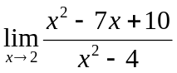

- Evaluate 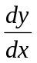 for

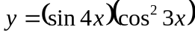

- Differentiate:

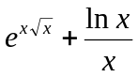

- Find the tangent line and the normal line to the curve at the point 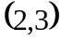:

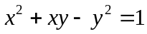

- An object moves along a line. The acceleration function is 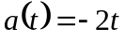. The initial velocity is 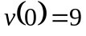.

Find the velocity function 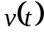.

For the time interval 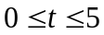, find the total distance traveled. (Remember that total distance is the amount that would be registered on an odometer. It is not, necessarily, displacement.)

- The length of a rectangle is increasing at a rate of 6 cm./sec., and its width is increasing at a rate of 7 cm./sec. When the length is 5 cm. and the width is 8 cm. how fast is the area of the rectangle increasing?

- Integrate:

